**ASSIGNMENT – 8**

Report by Bhavana Sree Naidu Yeluri

Contents

1. Project Overview
2. Frontend Screenshots
3. System Architecture
4. Eureka Dashboard
5. Docker
6. MongoDB Screenshots
7. Postman Screenshots
8. Email Notification
9. Message Broker – RabbitMQ
10. SonarQube
11. Jacoco
12. Jmeter
13. Newman
14. Swagger
15. Config Server

**Project Overview**

* + Developed a responsive **Angular-based frontend** for a flight booking platform.
  + Implemented **user authentication flows** including login and registration with **JWT**-based session handling.
  + Built **flight search, booking history, and admin inventory**.
  + Integrated **role-based navigation** to redirect users and admins to appropriate pages.
  + Used **HTTP interceptors** for automatic Bearer token attachment to secured API requests.

**Frontend Screenshots**

* Landing page

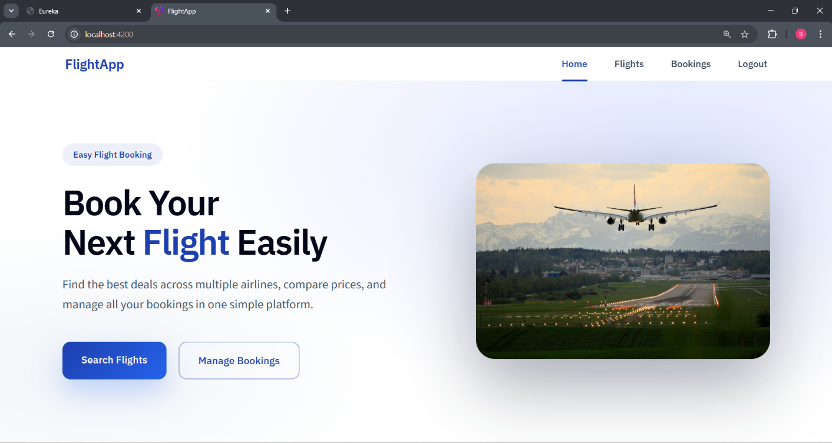

* Search Flights

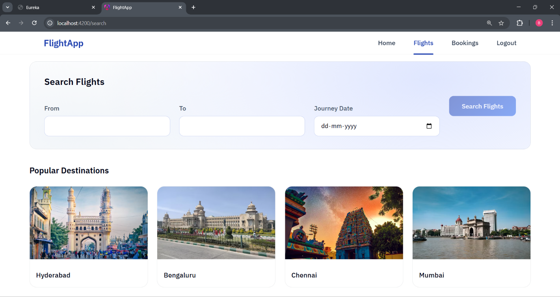

* Search Flights Results

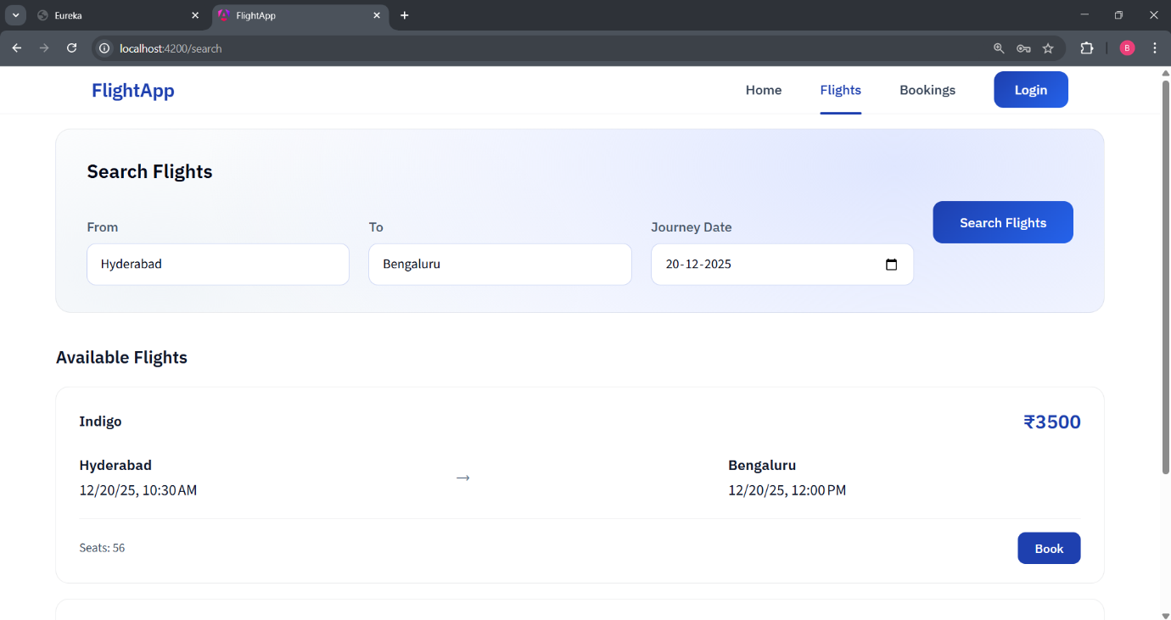

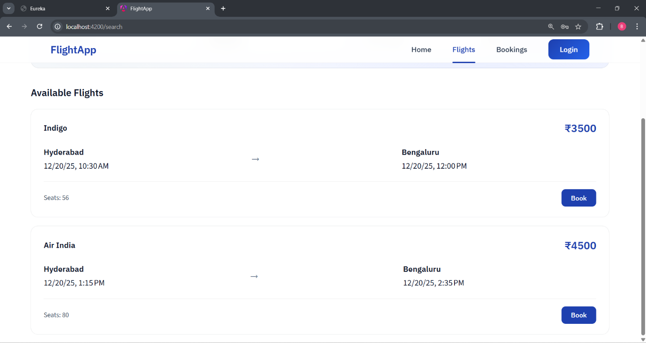

* Admin Dashboard

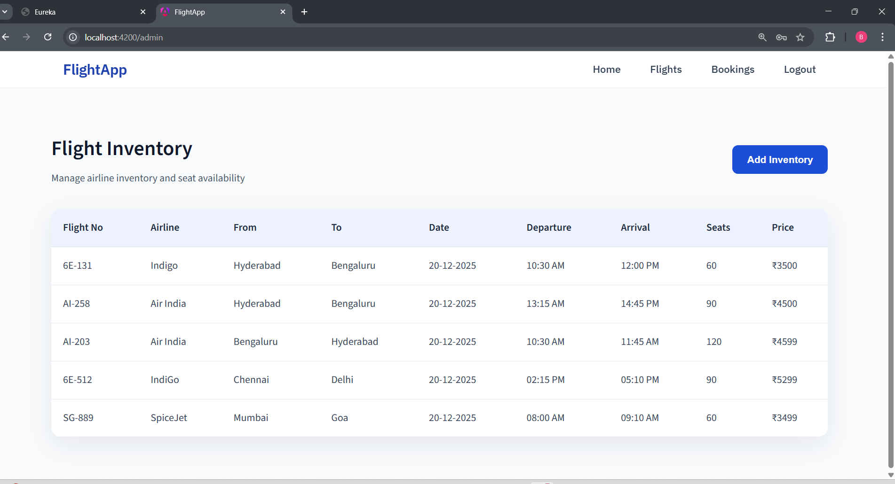

* User Dashboard

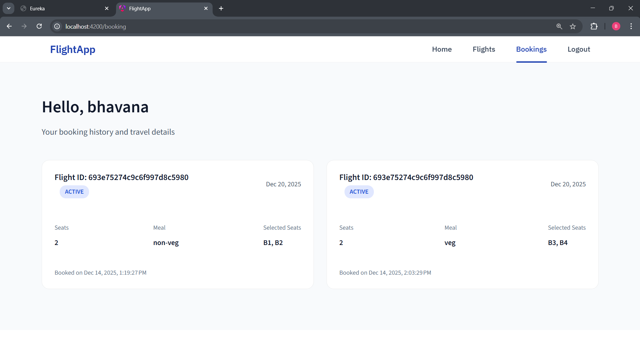

* Register

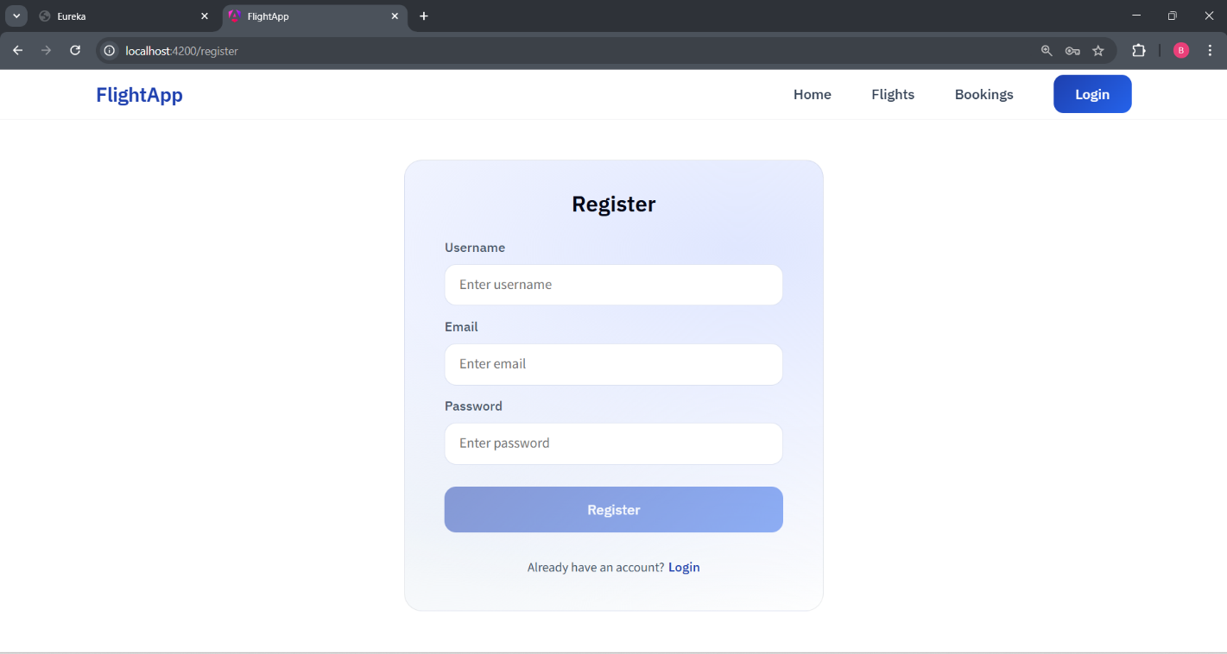

* Login

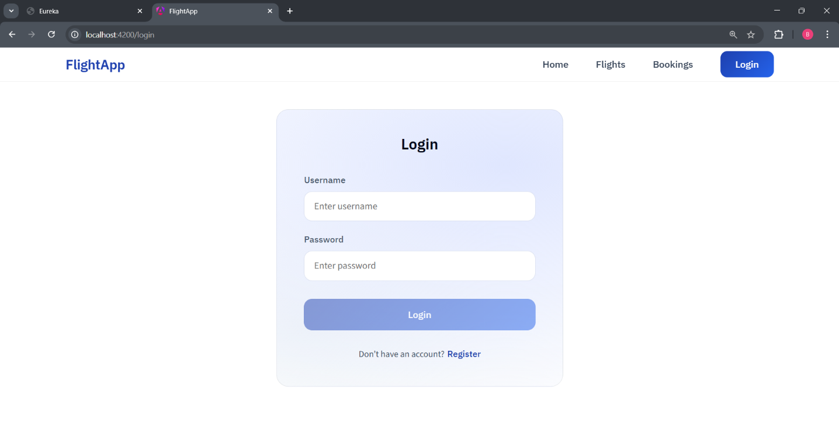

* Validations
* Invalid username

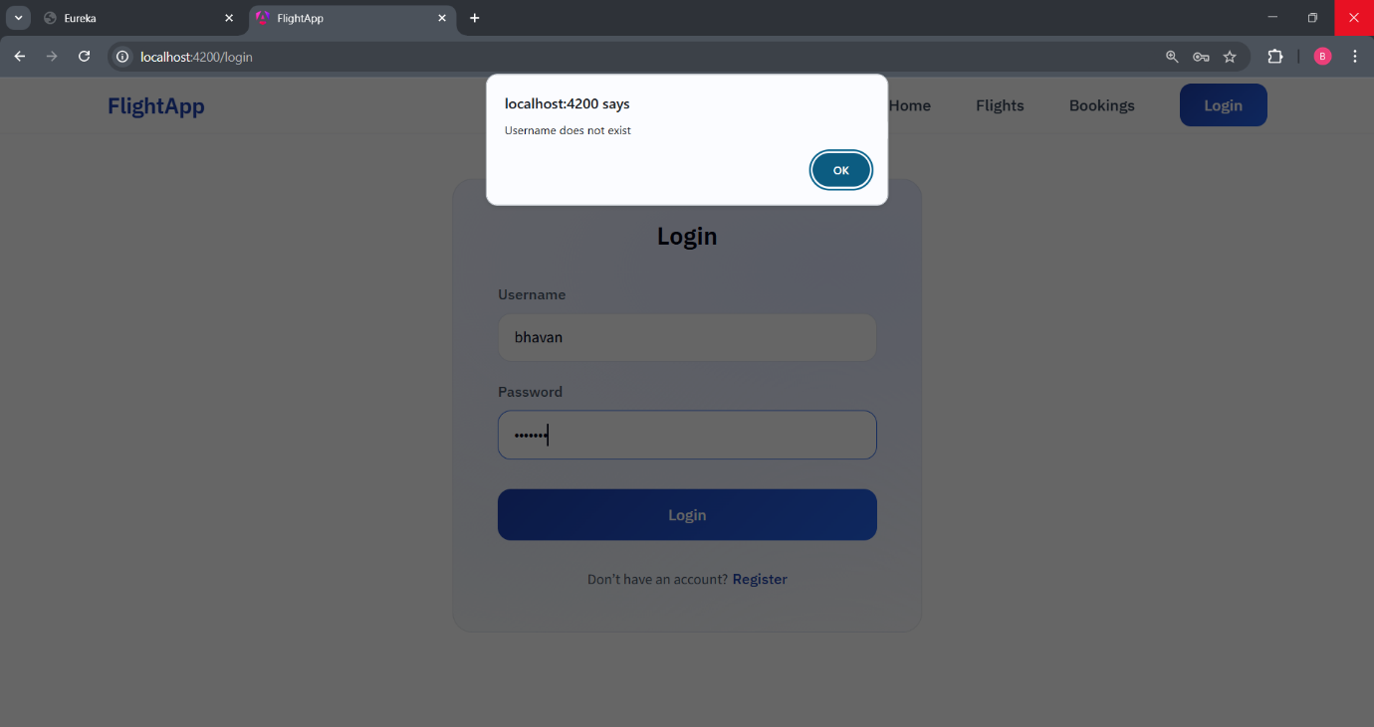

* Invalid password

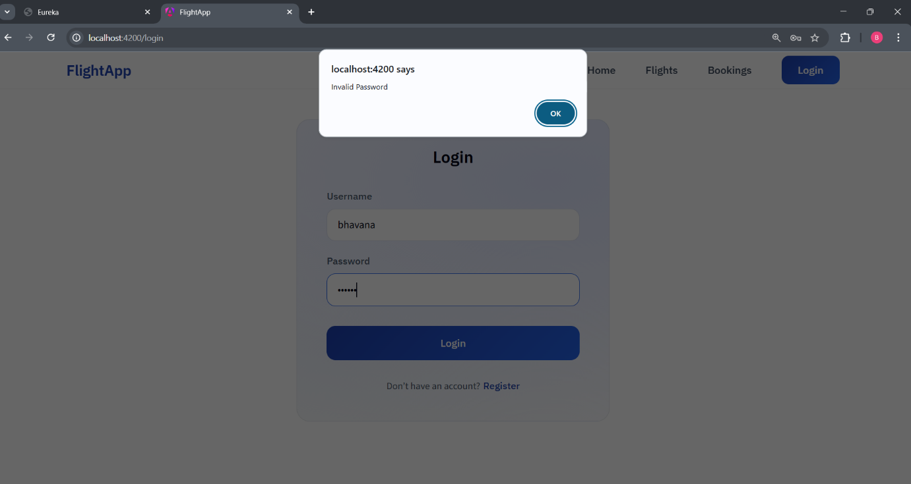

* Username already taken

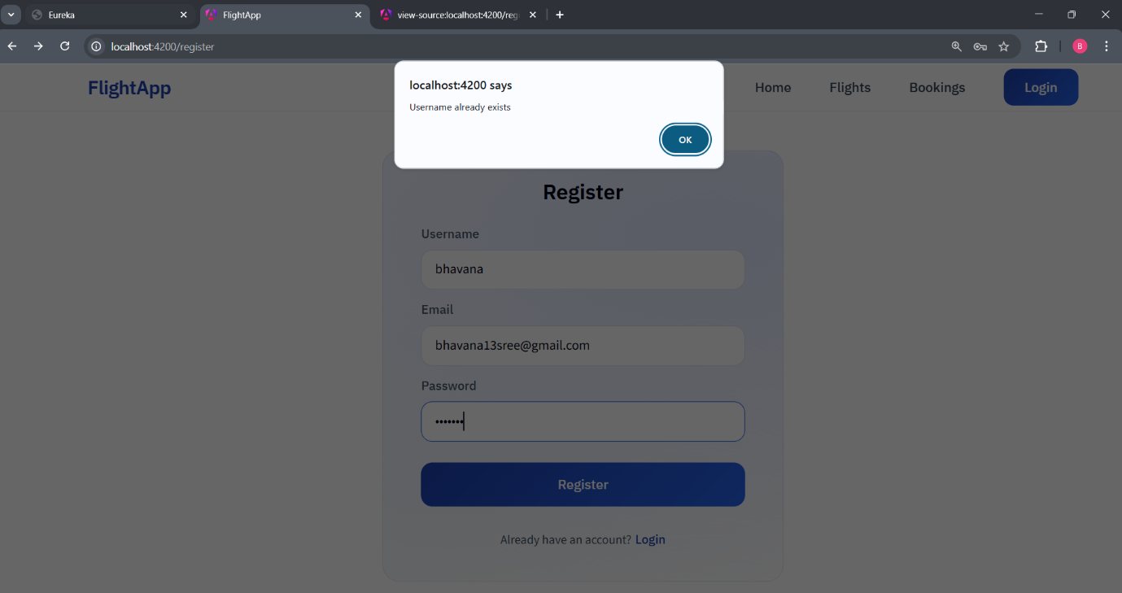

* Email already in use

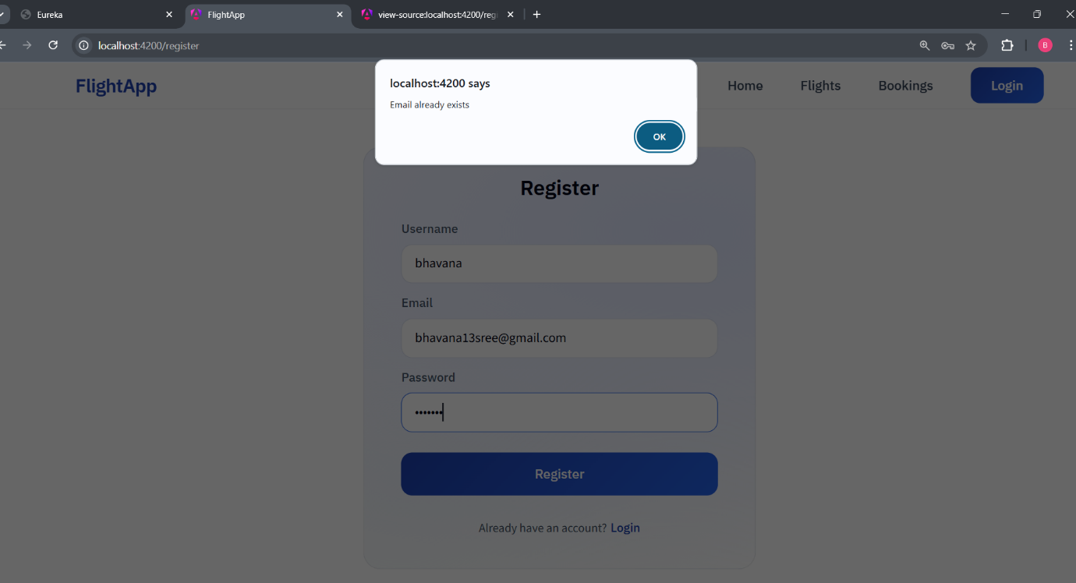

**System Architecture**

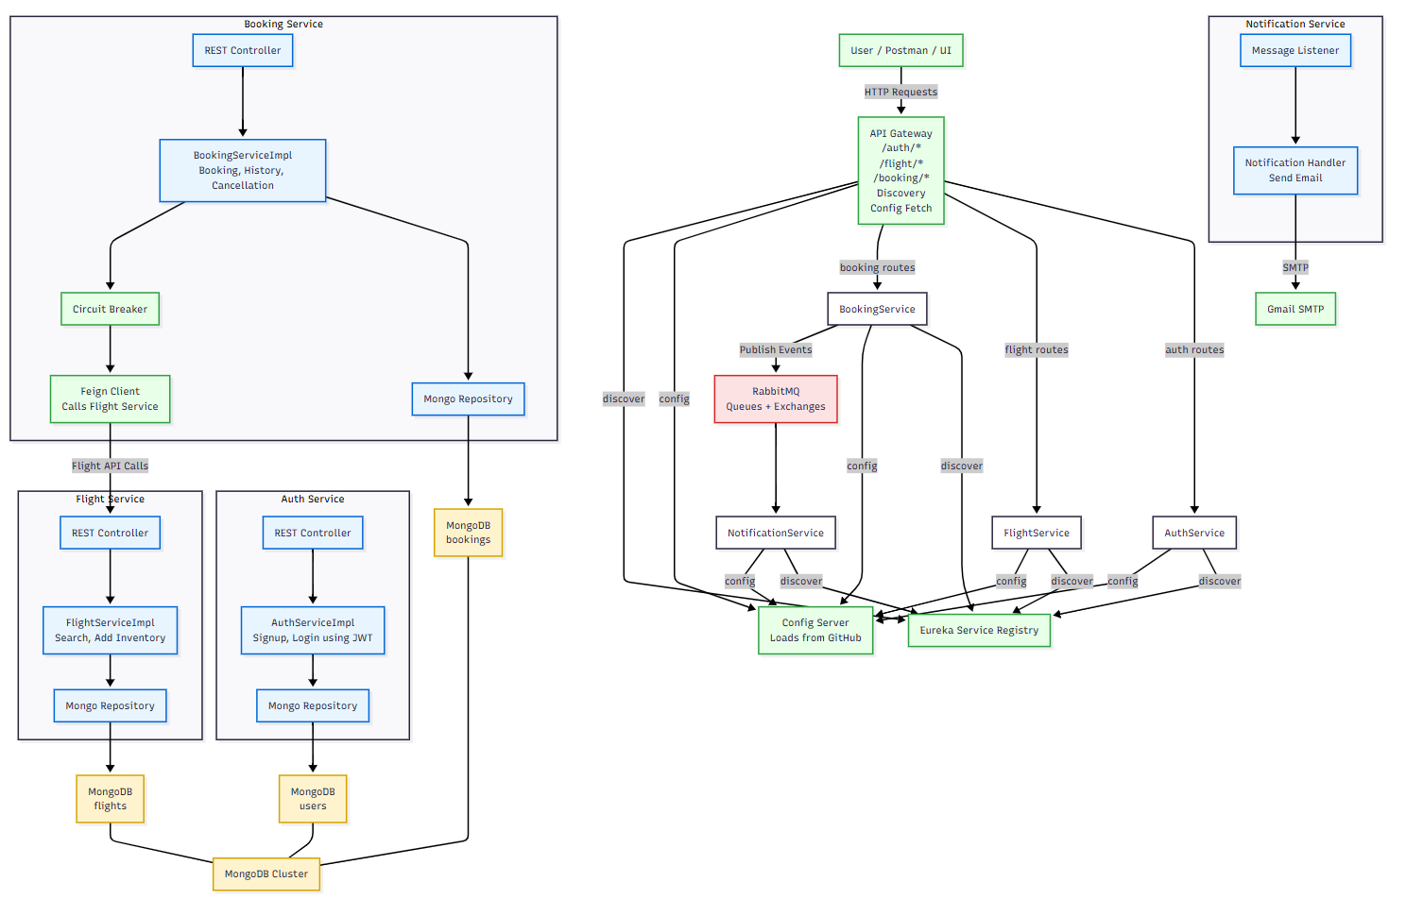

**Eureka Dashboard**

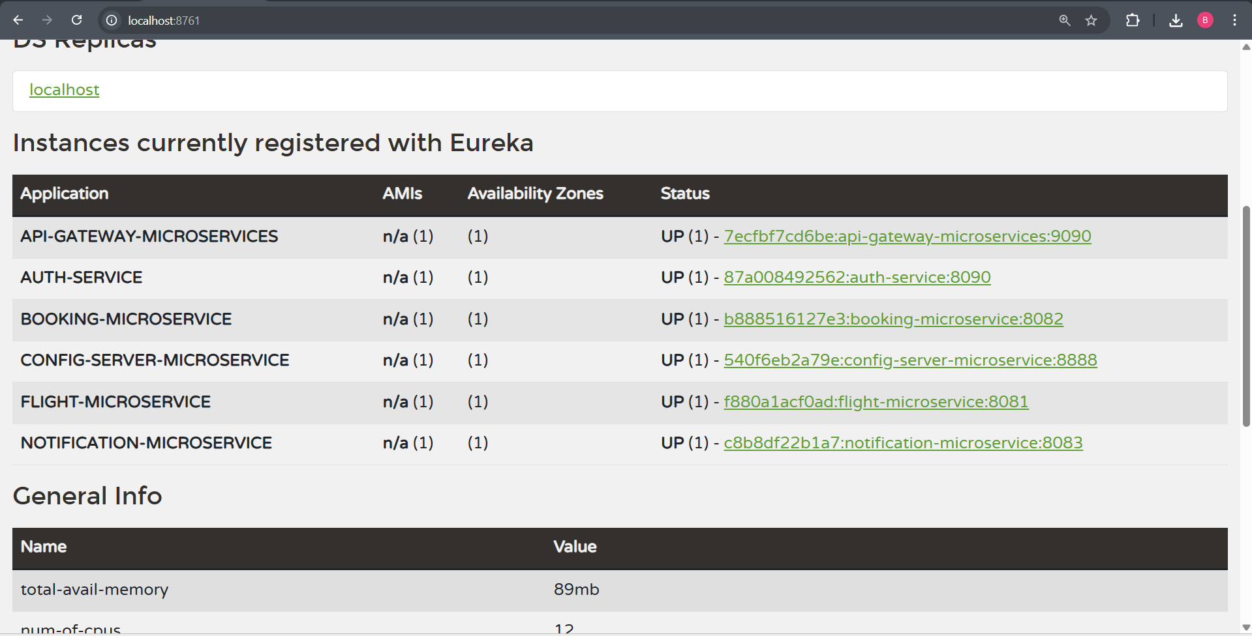

**Docker**

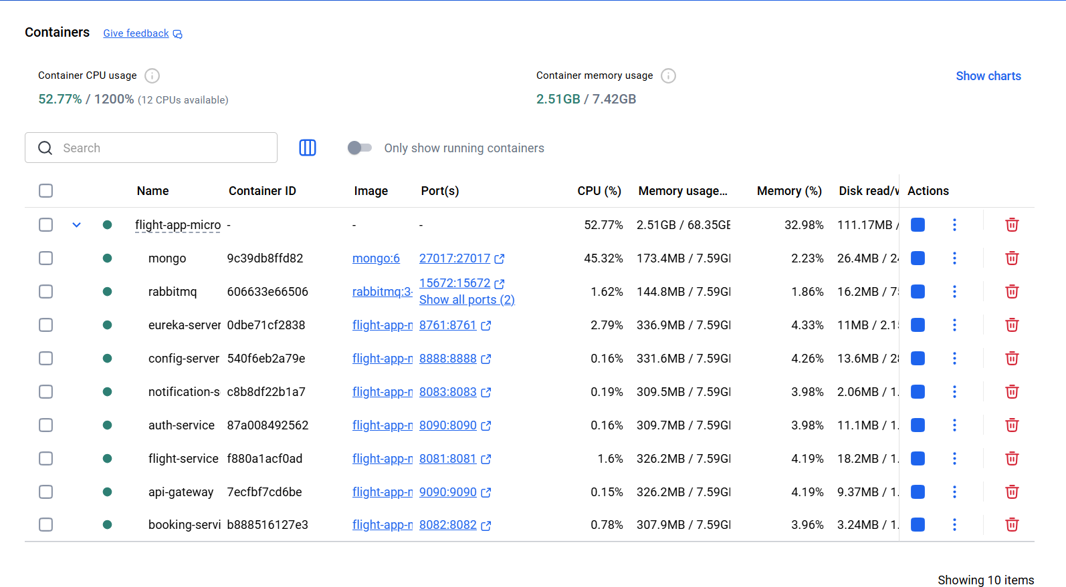

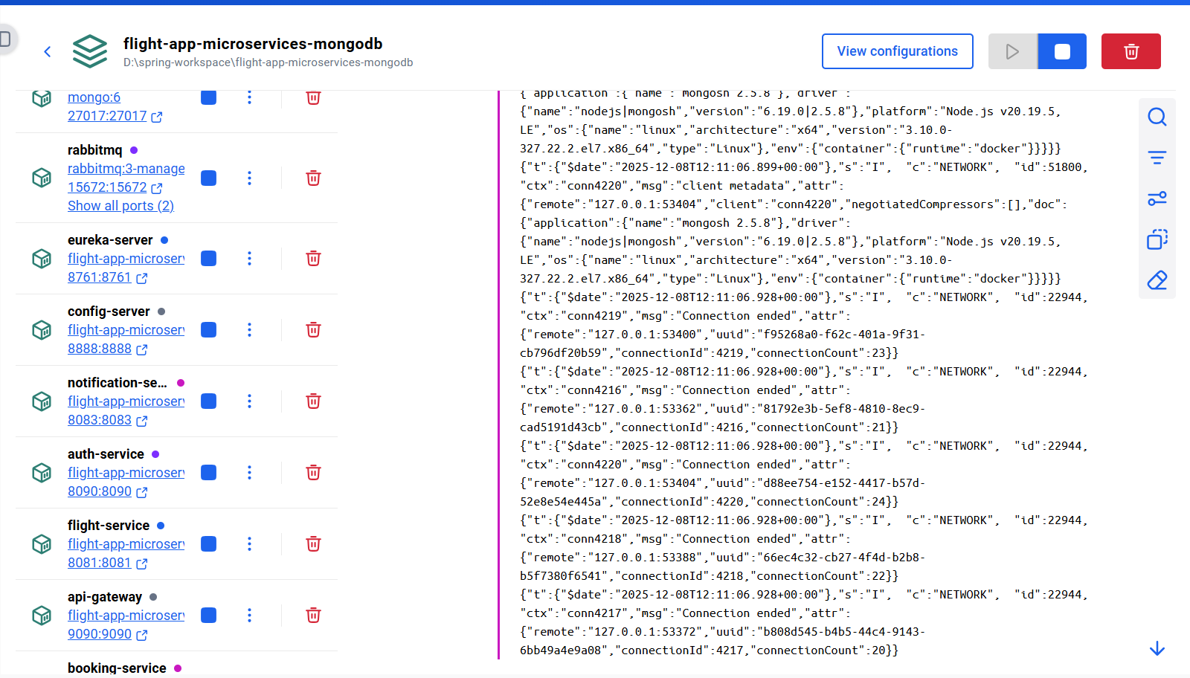

**MongoDB Screenshots**

* Roles in authdb

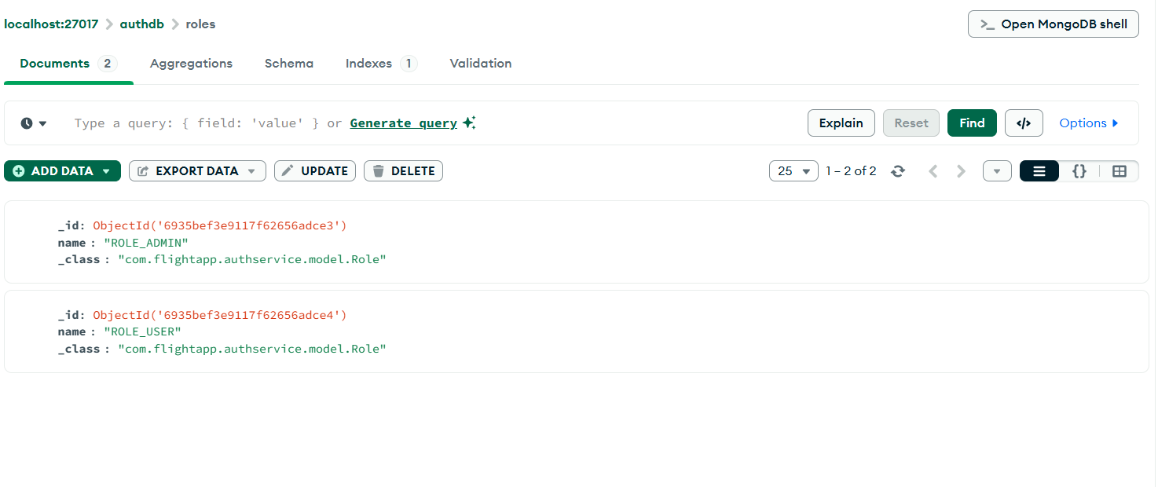

* Users in authdb

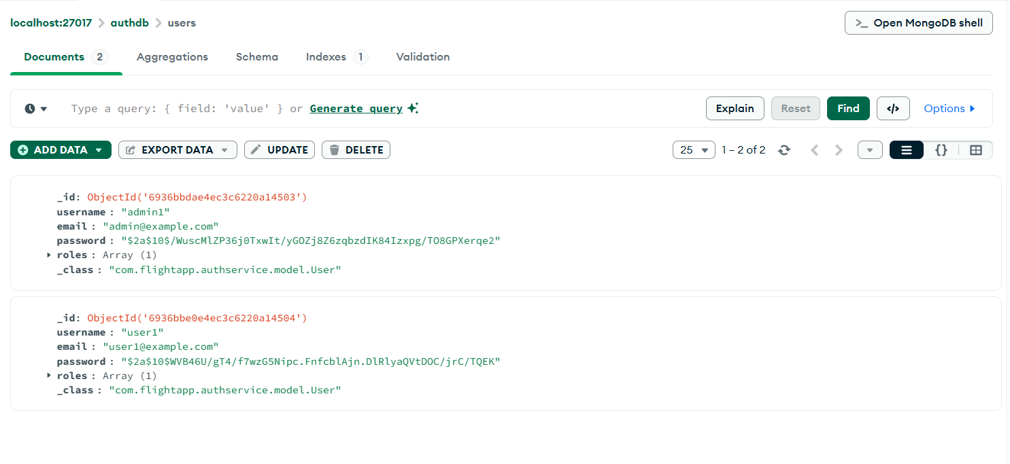

* Bookings in bookingdb

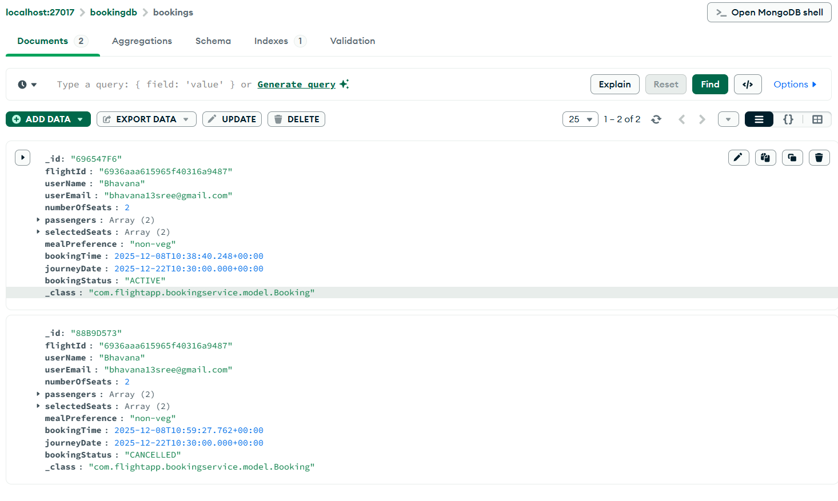

* Flights in flightdb

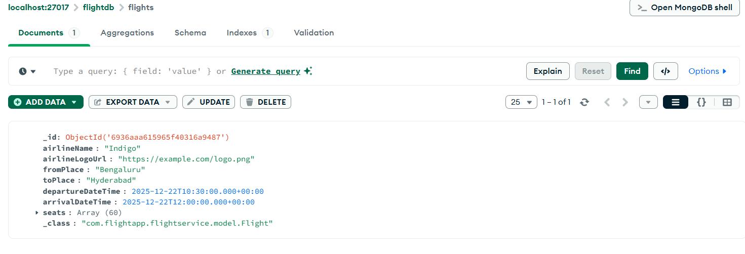

**Postman Screenshots**

* Admin signup

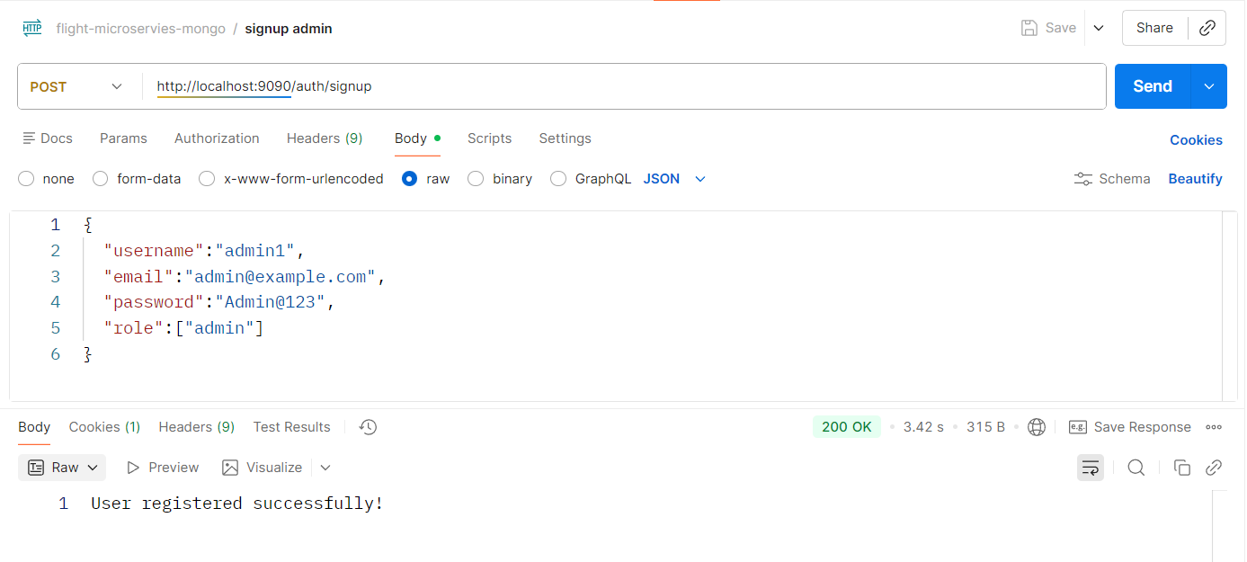

* Admin sign in

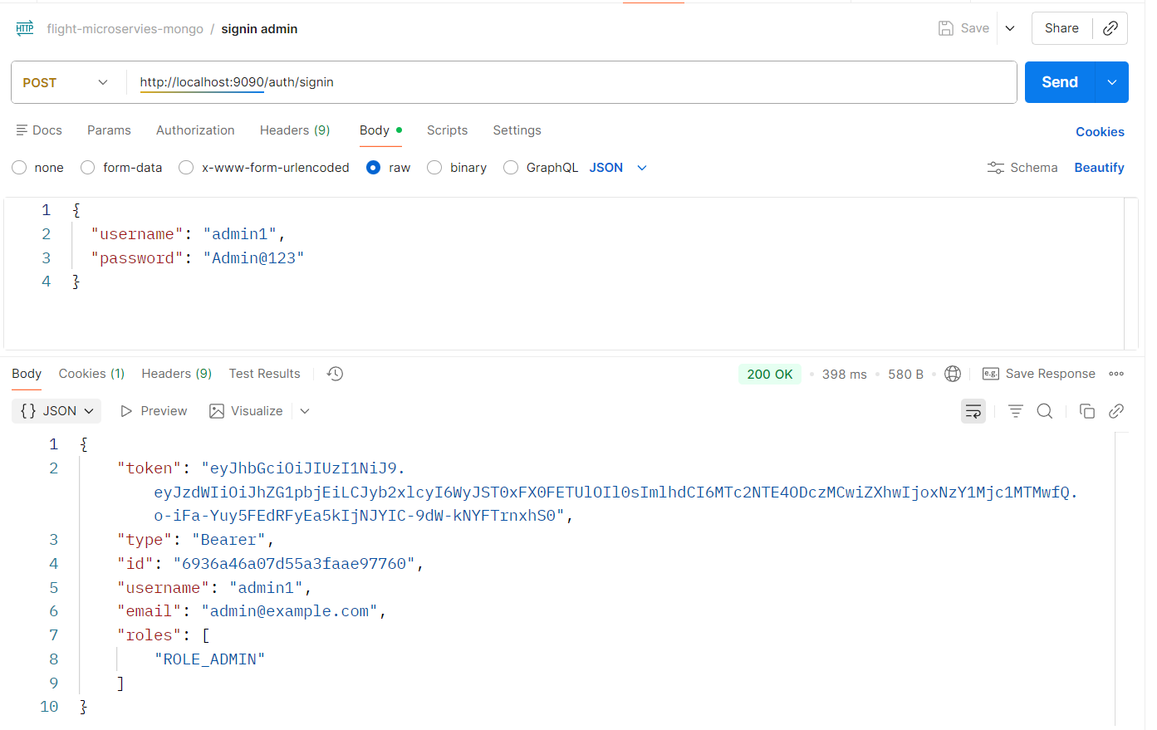

* Add Inventory – admin route

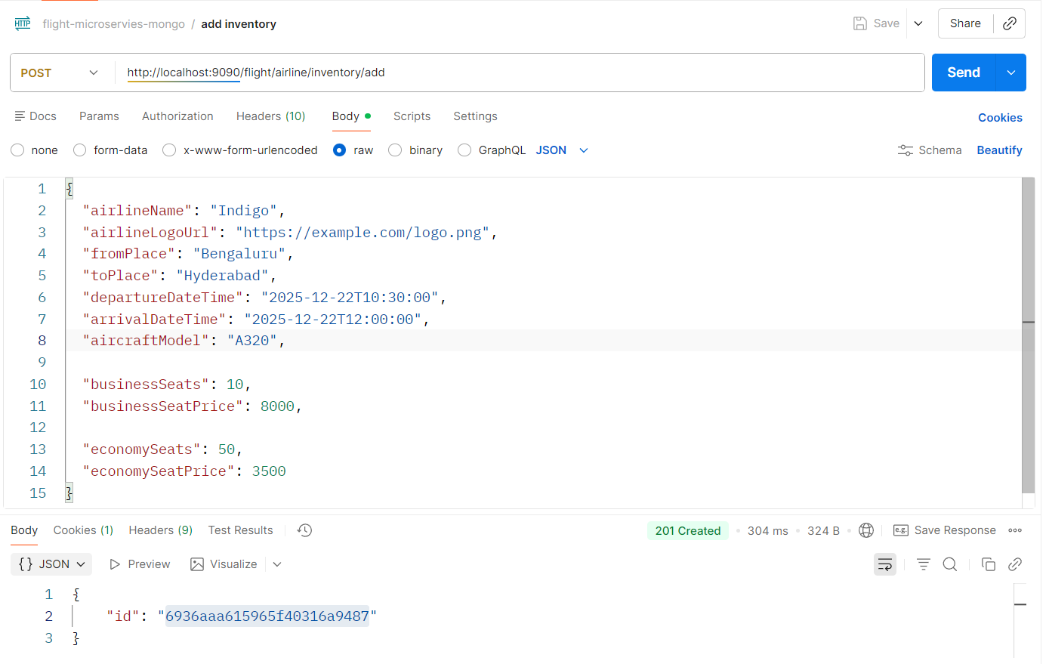

* User signup

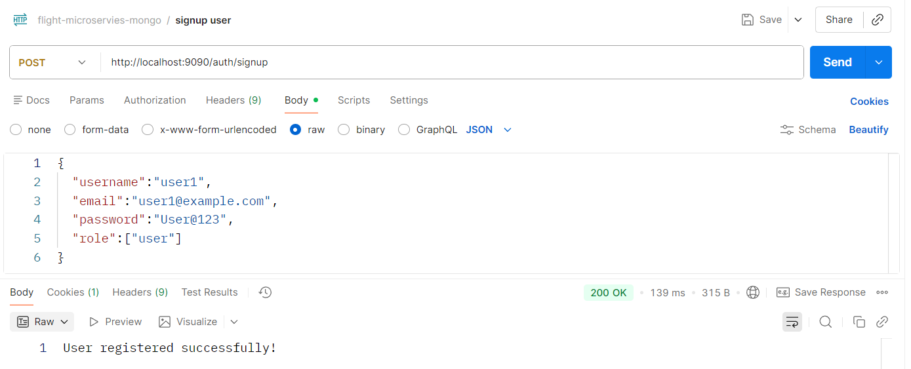

* User sign in

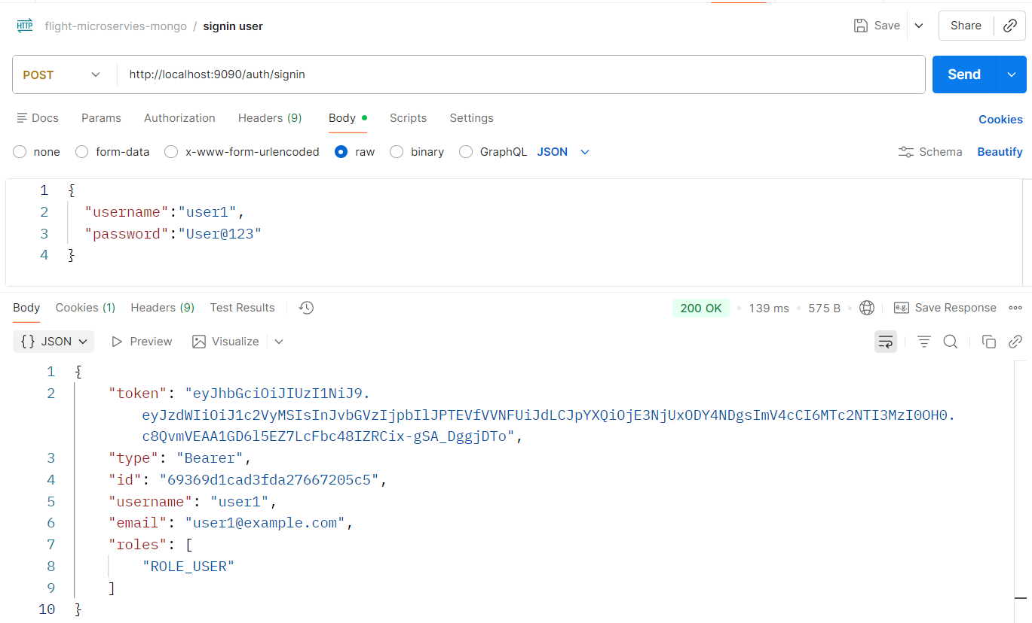

* Cancel ticket – user route

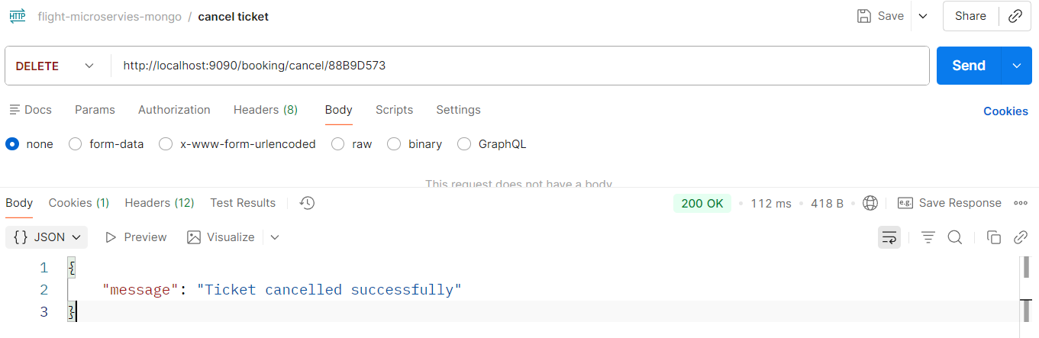

* Book flight – user route

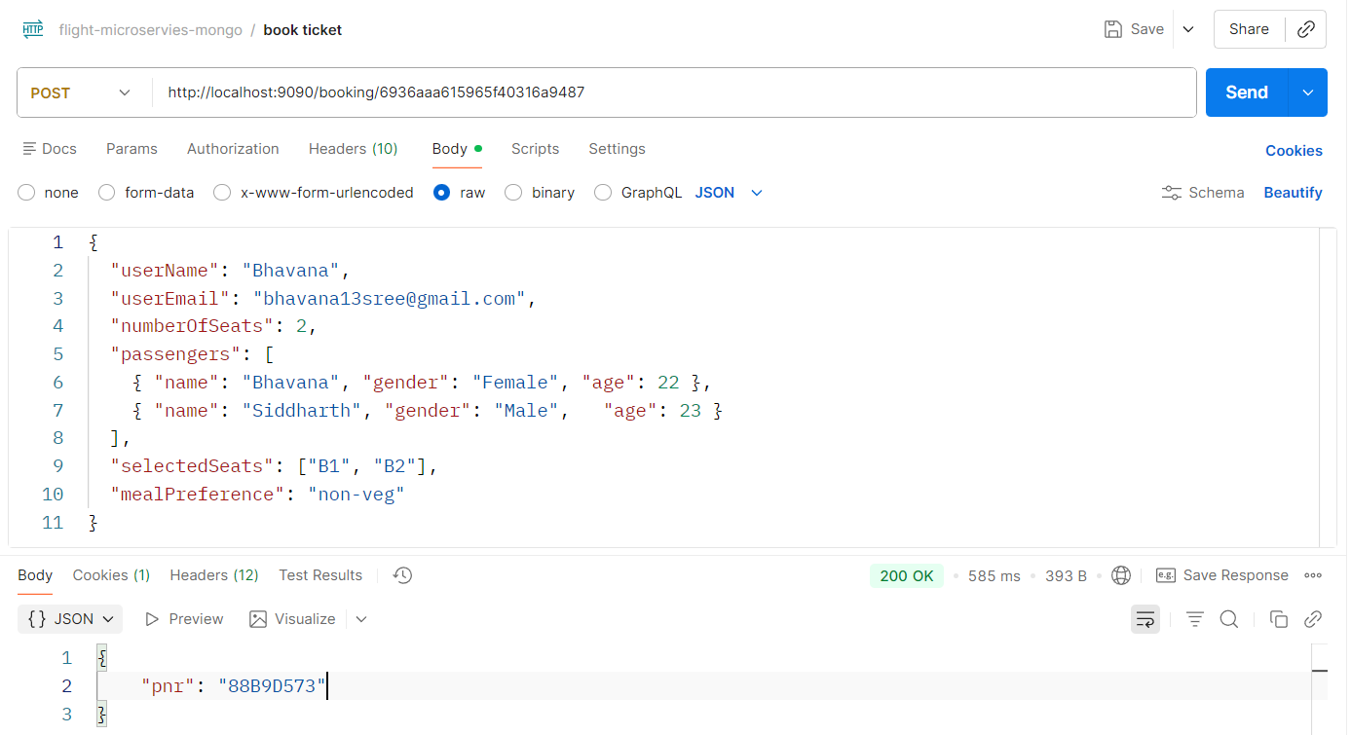

* Get history using email – user route

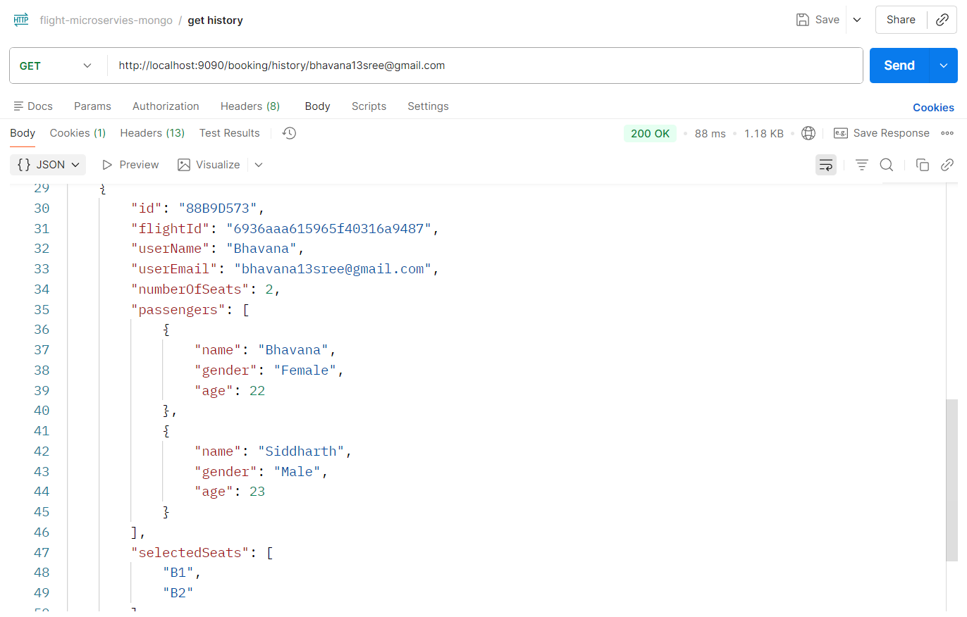

* Get ticket by PNR – user route

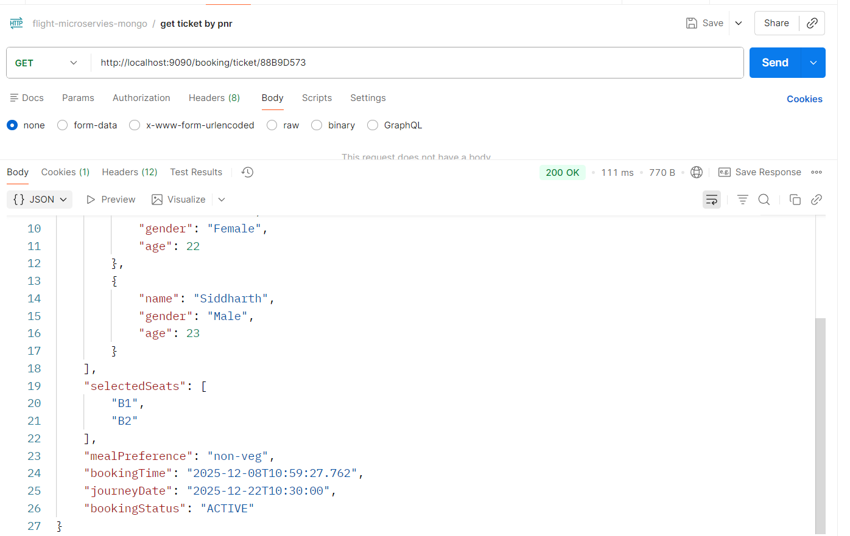

* Search Flight – user route

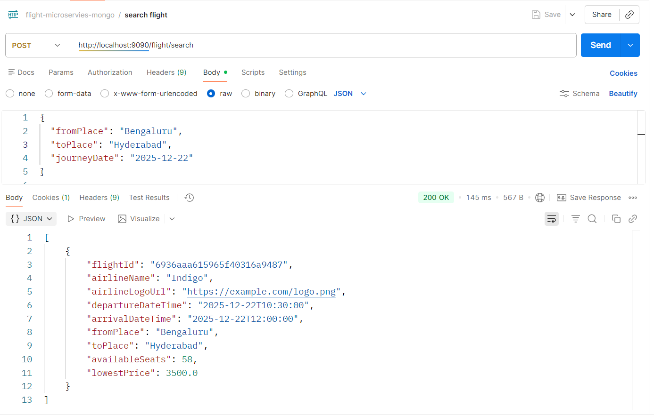

**Email Notification**

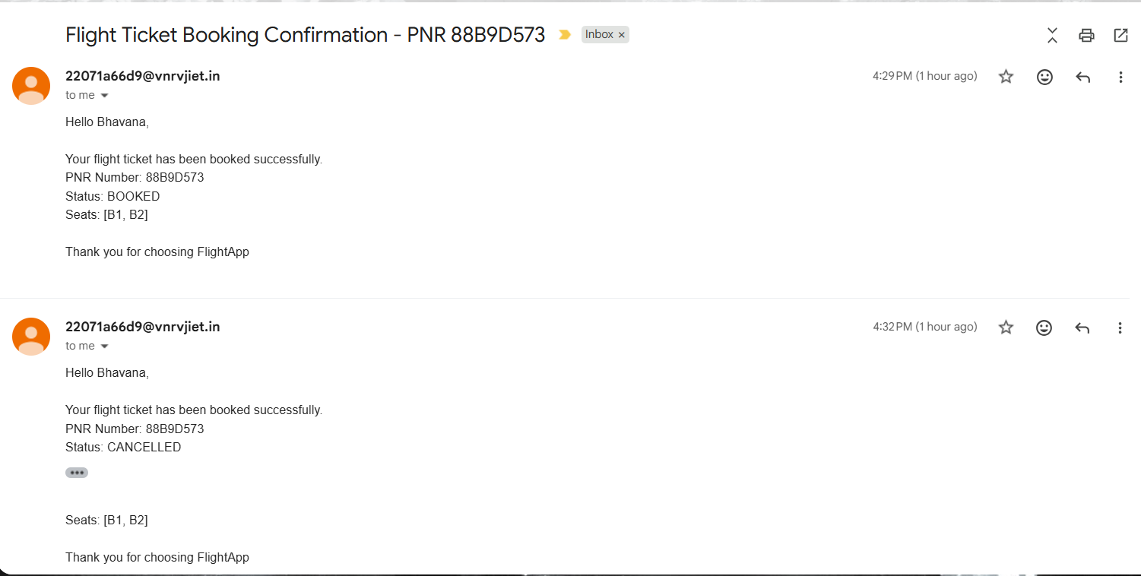

**Message broker – RabbitMQ**

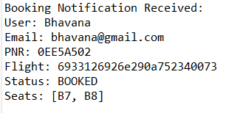

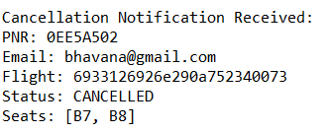

**Sonarqube**

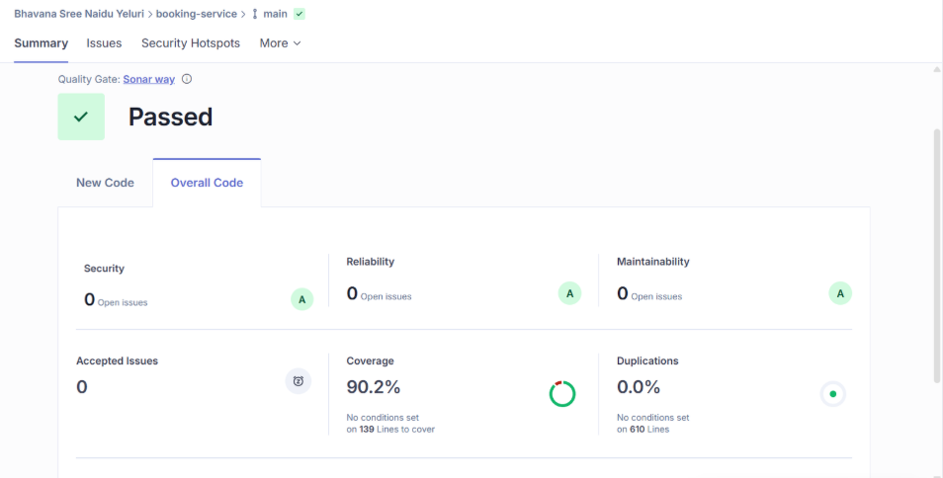

**Jacoco**

* + **95% coverage**

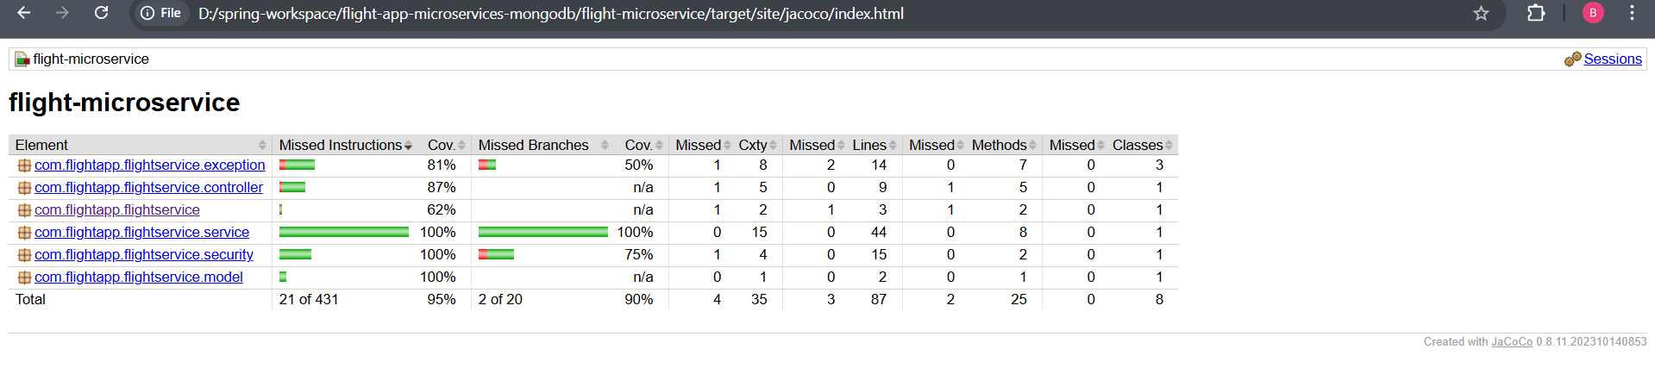

**Jmeter**

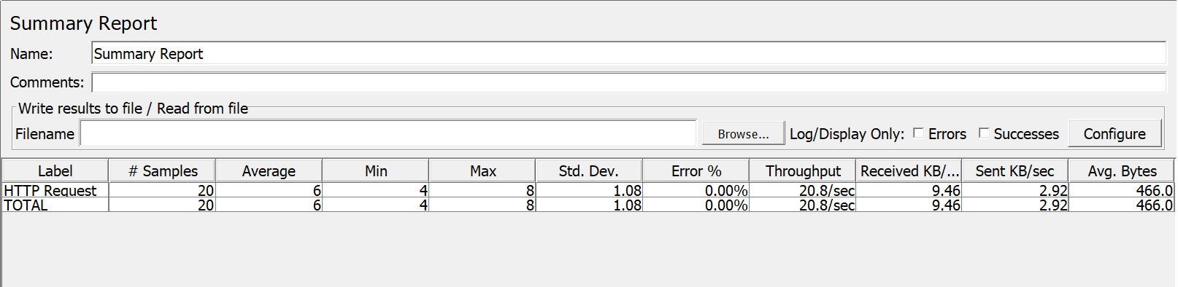

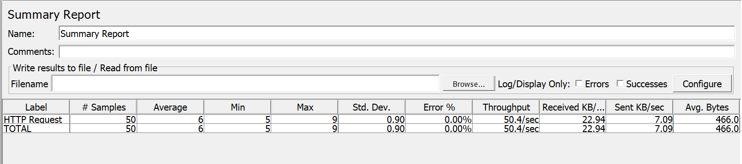

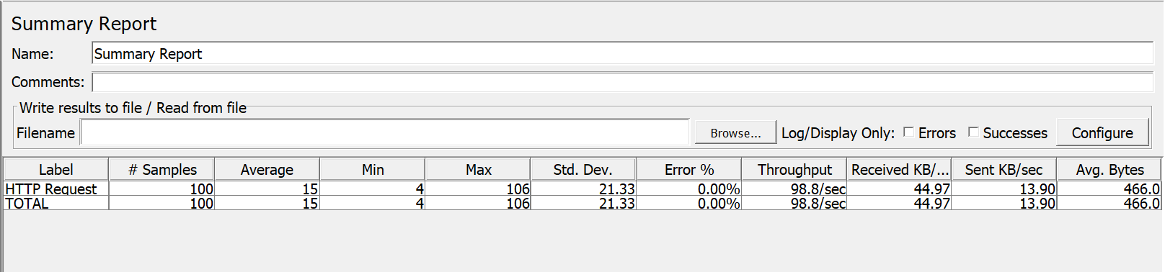

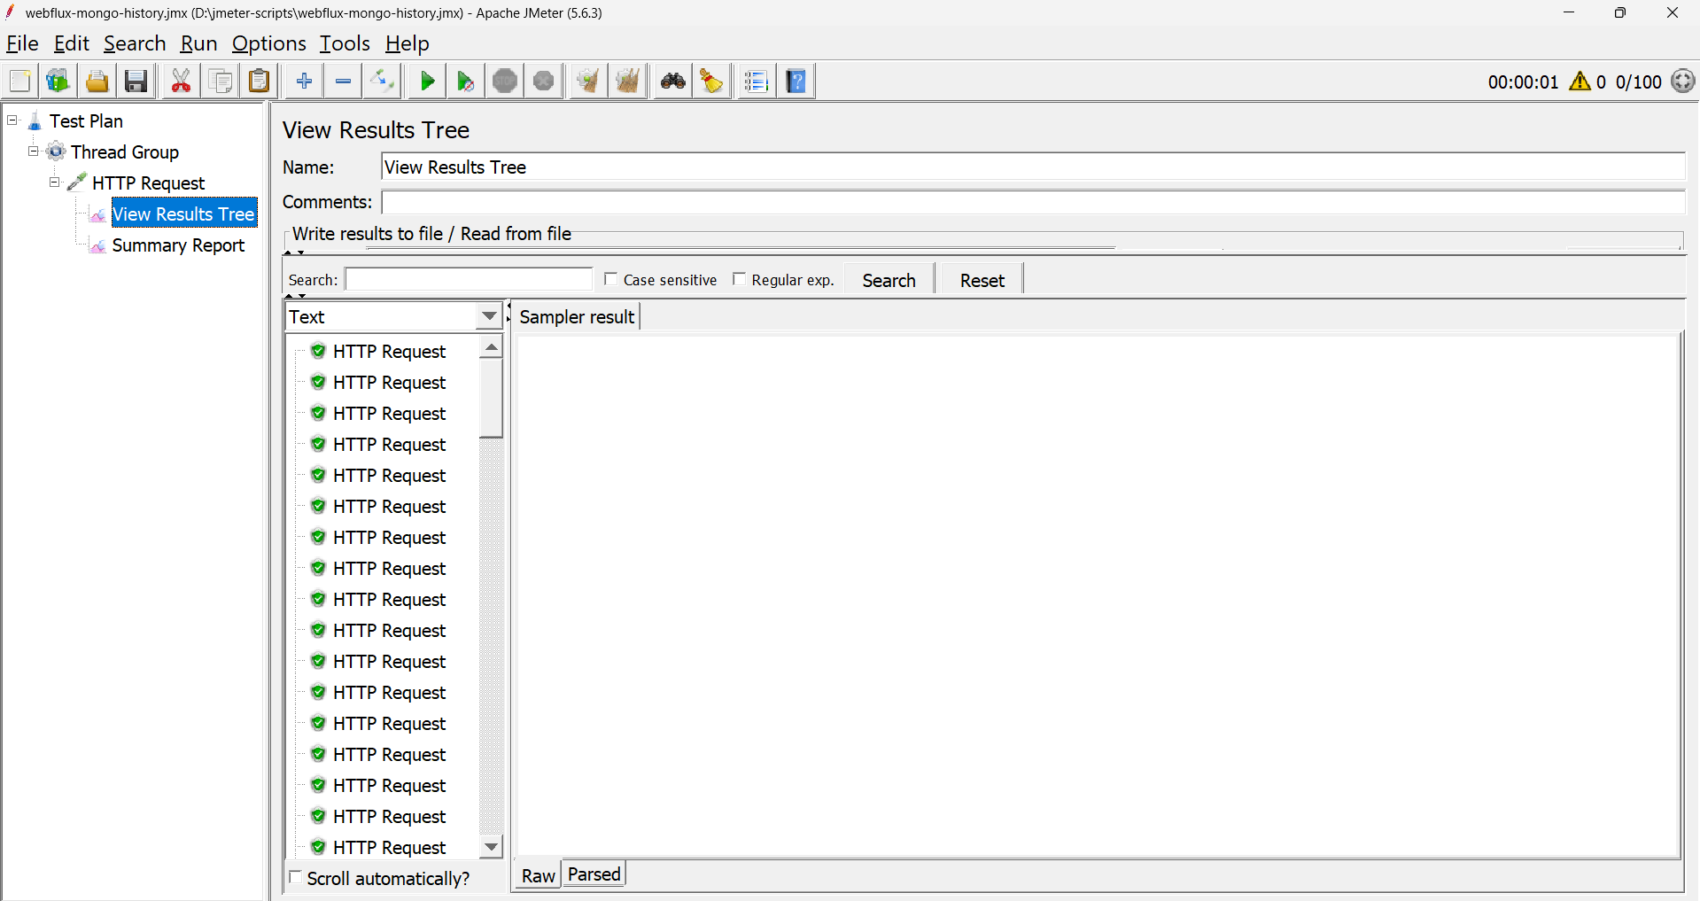

**Newman**

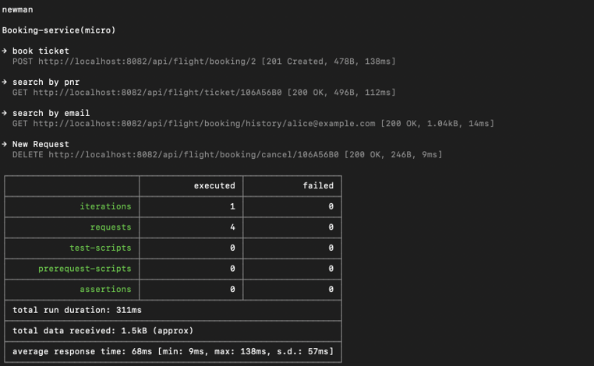

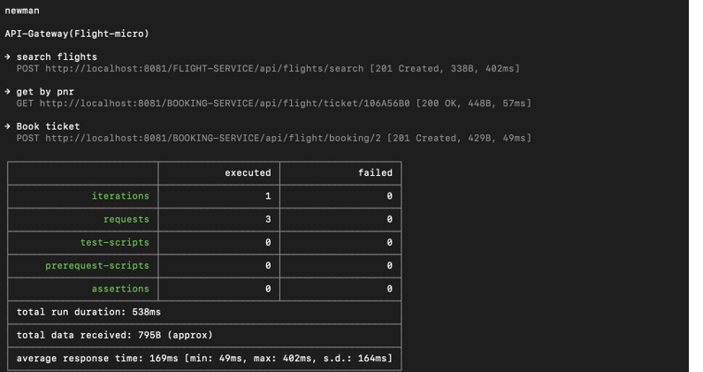

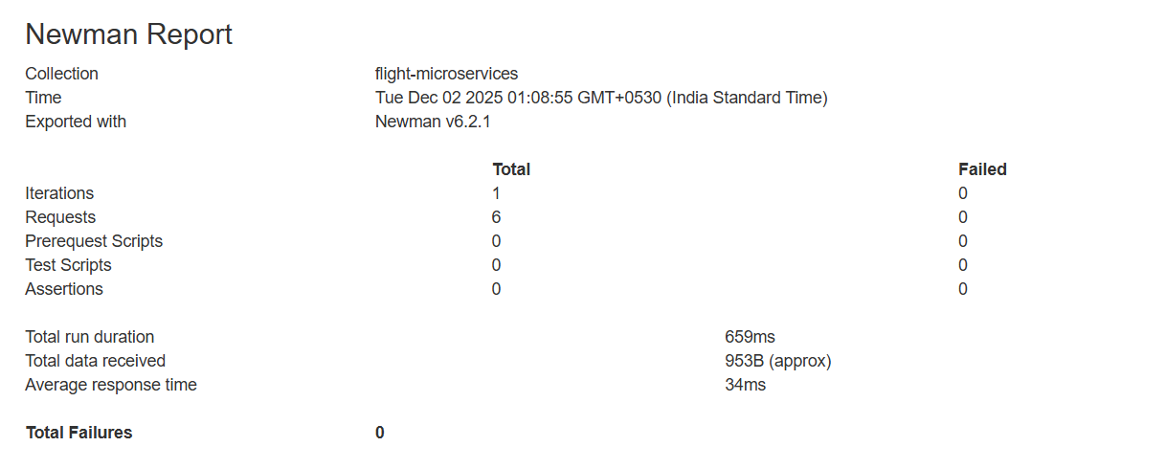

**Swagger**

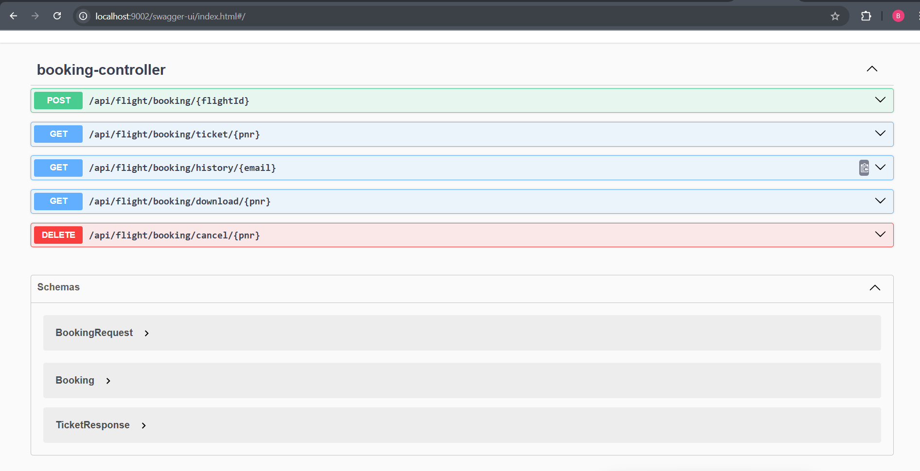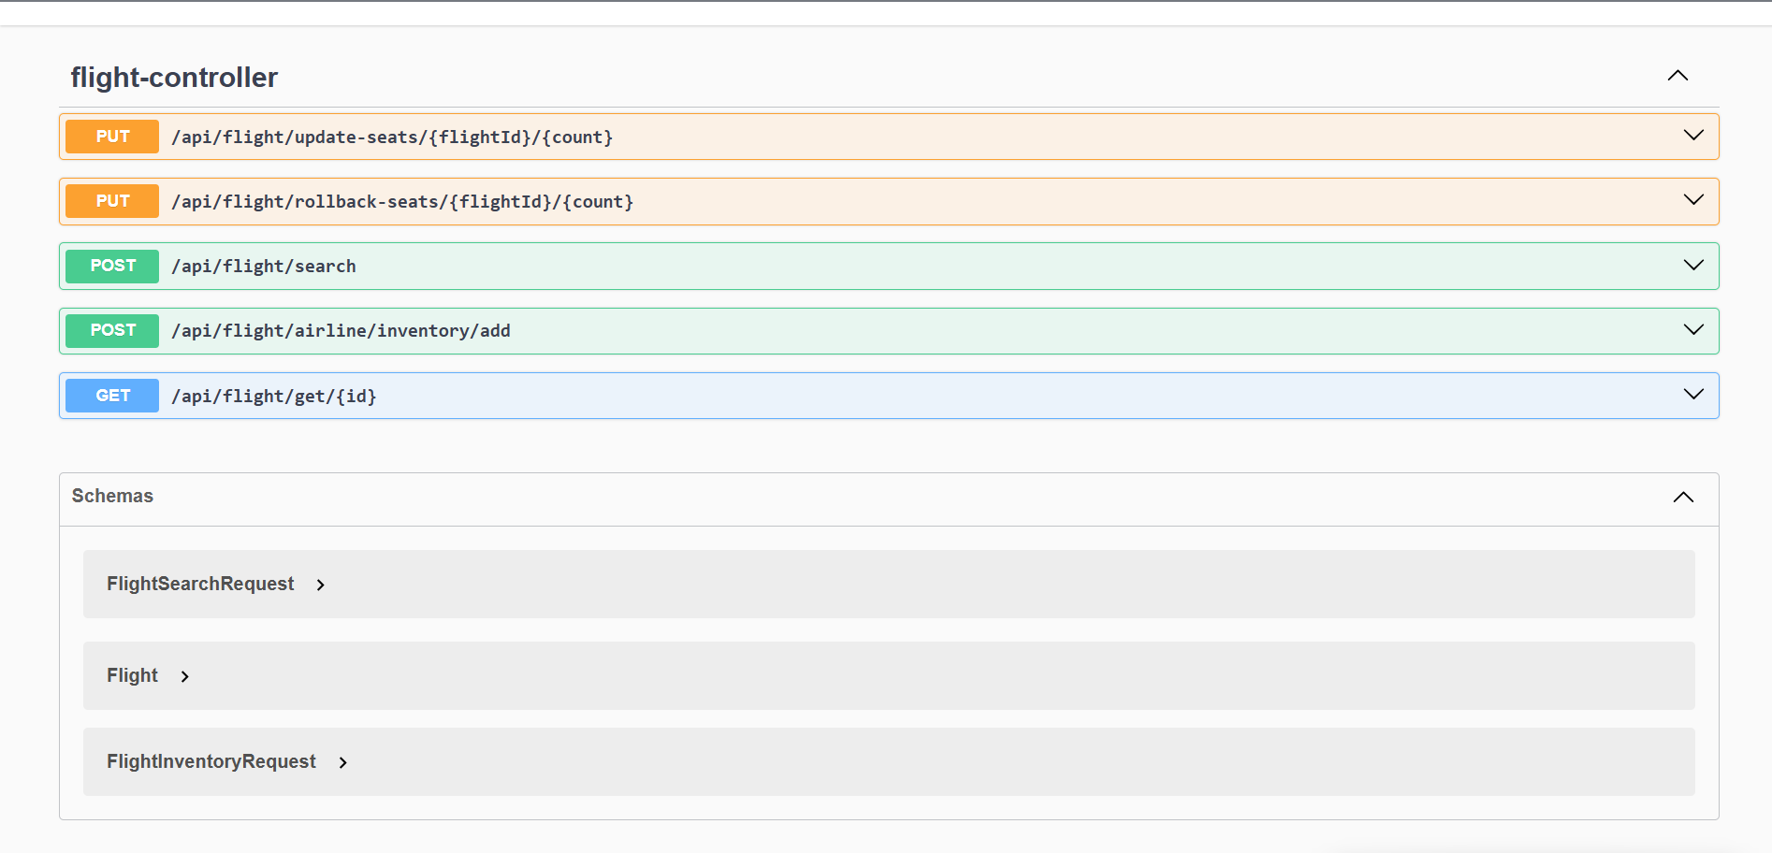

**Config Server**

